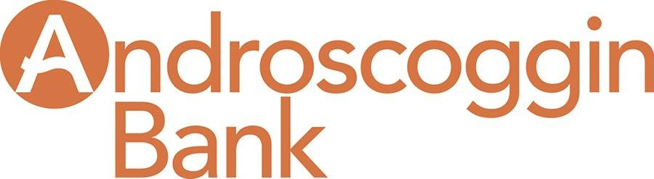

Cybersecurity Resources
US Department of Health & Human Services Cybersecurity Guidance
https://www.hhs.gov/hipaa/for-professionals/security/guidance/cybersecurity/index.html

Eset – Offers both free and paid Cybersecurity Awareness Training Online
https://www.eset.com/us/cybertraining/

Federal Trade Commission
Data Security Resources for Small Business
https://www.ftc.gov/tips-advice/business-center/privacy-and-security/data-security

U.S. Small Business Administration
https://www.sba.gov/managing-business/cybersecurity

Federal Communications Commission Custom Cyber Planner for Small Business
https://www.fcc.gov/cyberplanner

FCC Cybersecurity for Small Business
https://www.fcc.gov/general/cybersecurity-small-business

Stay Safe Online: Business Safe Online Resources Sponsored by National Cyber Security Alliance
https://staysafeonline.org/cybersecure-business/

Free Online Tools and Security Checkups
https://staysafeonline.org/stay-safe-online/free-online-security-checkups-tools/

Department of Homeland Security Cybersecurity Resource Page
https://www.dhs.gov/topic/cybersecurity

VISA Small Business Data Security Resources
https://usa.visa.com/support/small-business/data-security.html

